**SHREEYAM ACHARYA (23BCE2330)**

**WEB DA1**

***Create the homepage for a small bakery's website. The homepage should have the following sections:***

***1. A header with the bakery's name and a navigation menu with links to "Home," "About Us," "Menu," and "Contact."***

***2. A hero section with a background image of the bakery and a welcome message.***

***3. A section highlighting three featured baked goods with images, names, and brief descriptions.***

***4. A footer with the bakery's contact information and social media links.***

CODE

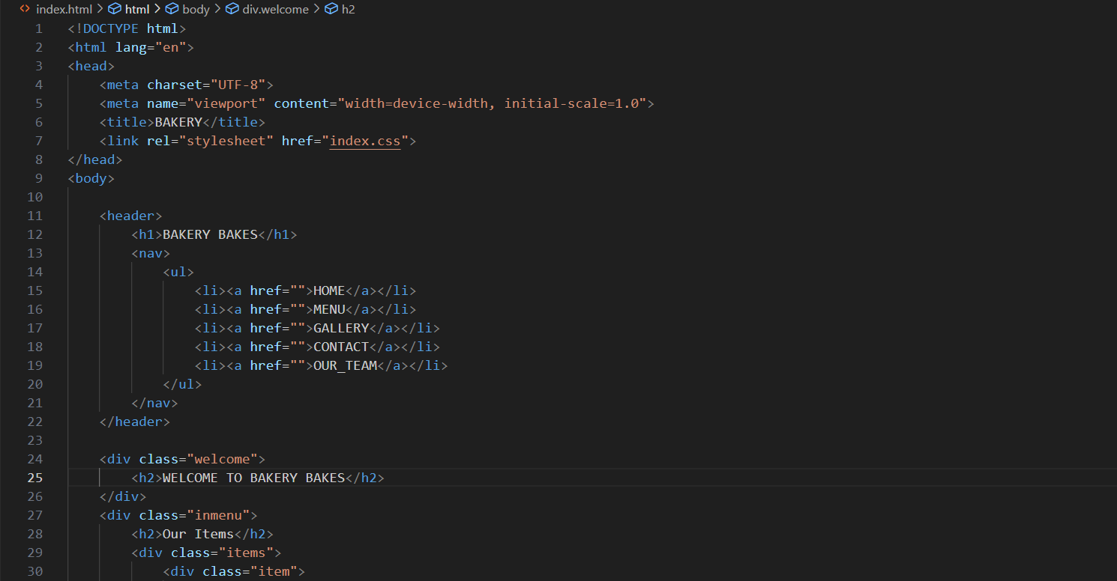

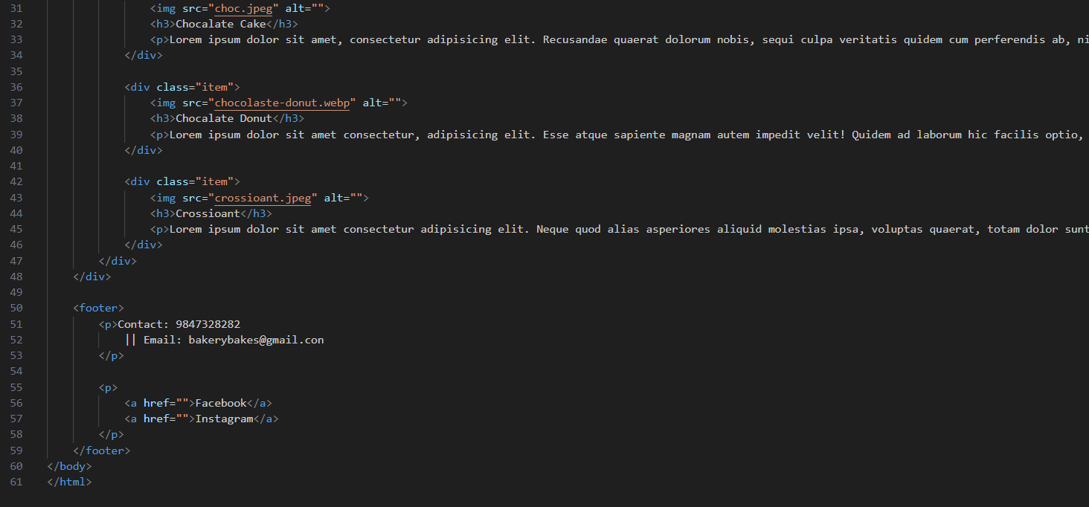

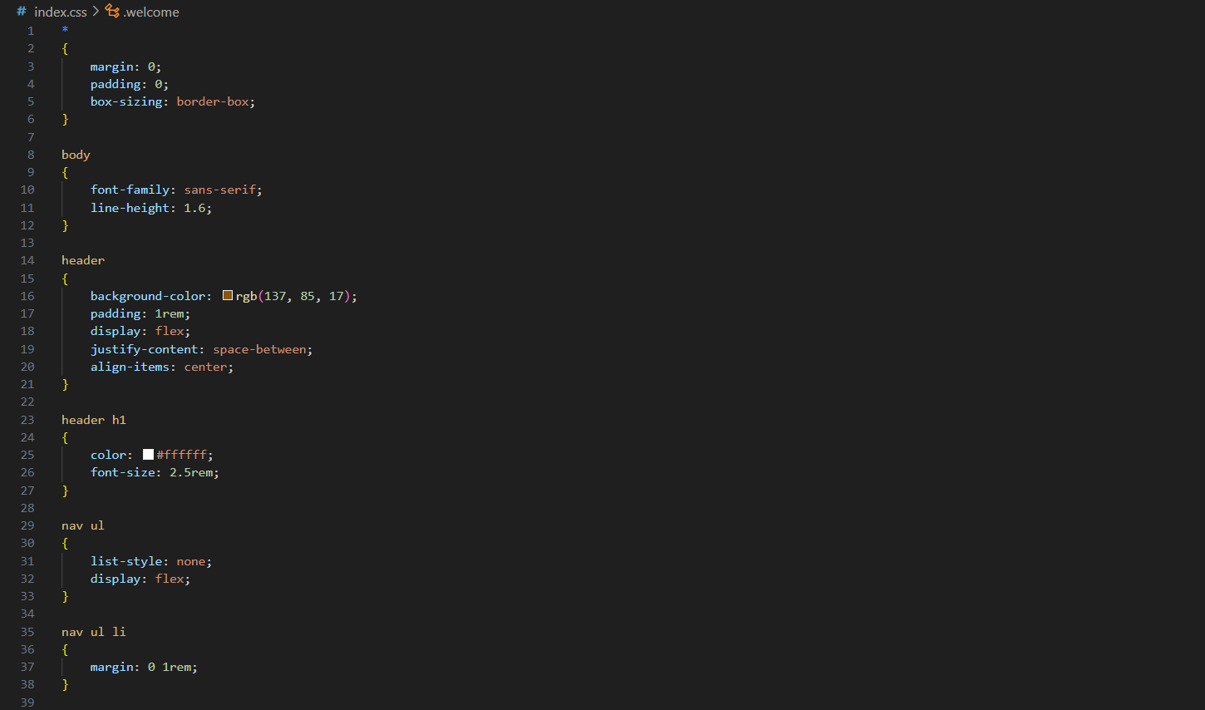

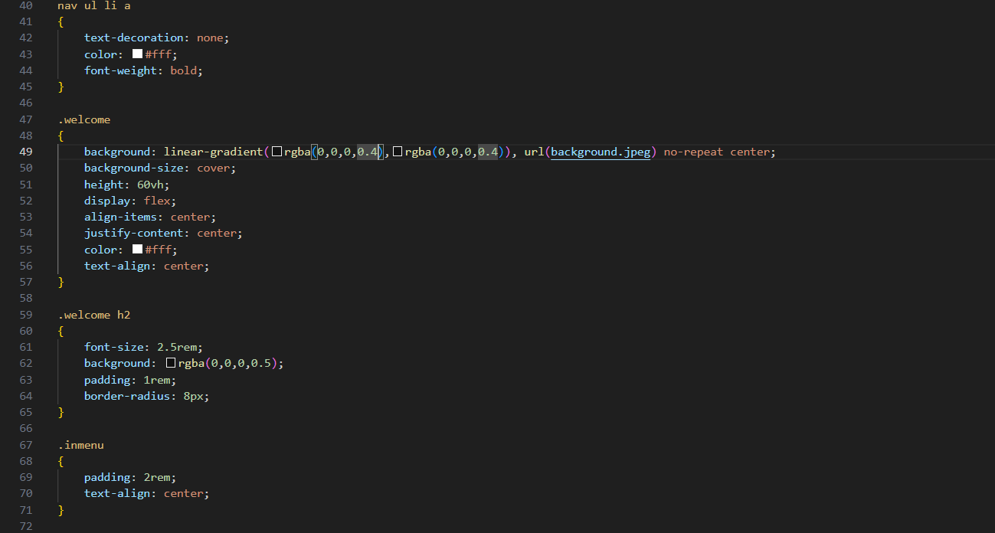

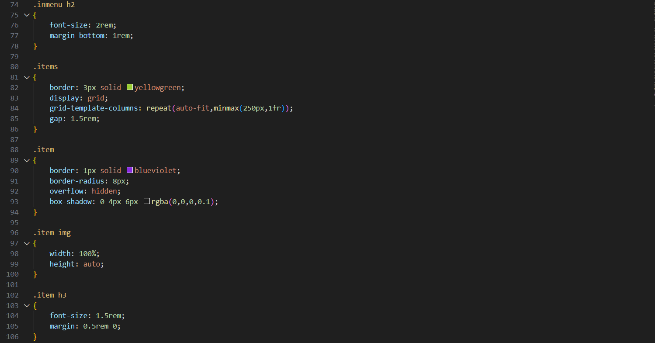

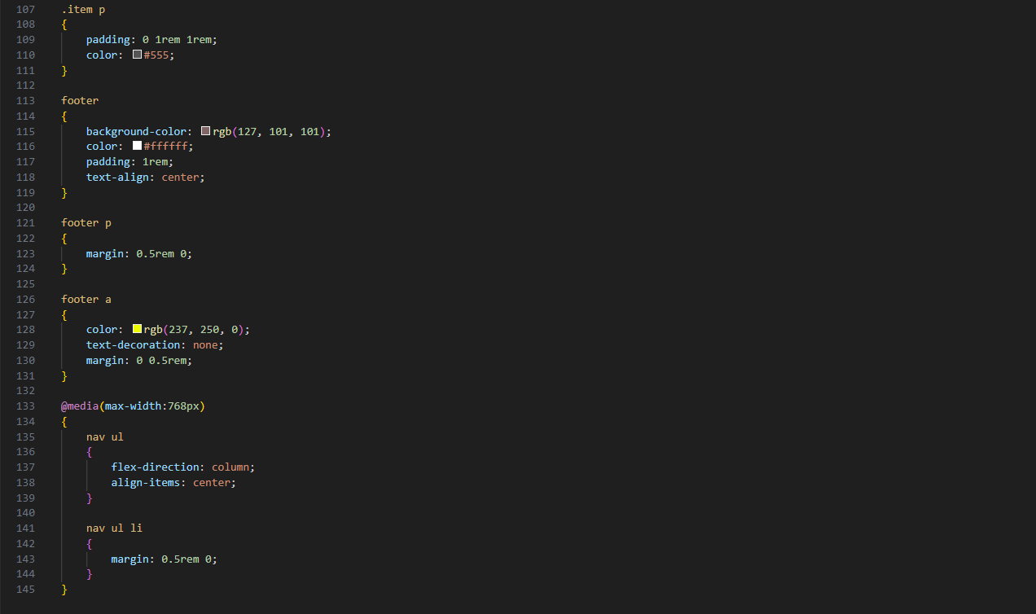

***Output***

